Following are the steps to install E-260U USB TV stick in Window 8.1
Follow the below instruction.
First, press win + I to launch the charm bar, and click Settings at the bottom.
Then, go to settings and scroll to the bottom of the page, click Change PC Settings
Button under Advanced Startup section. Remember to save all your work

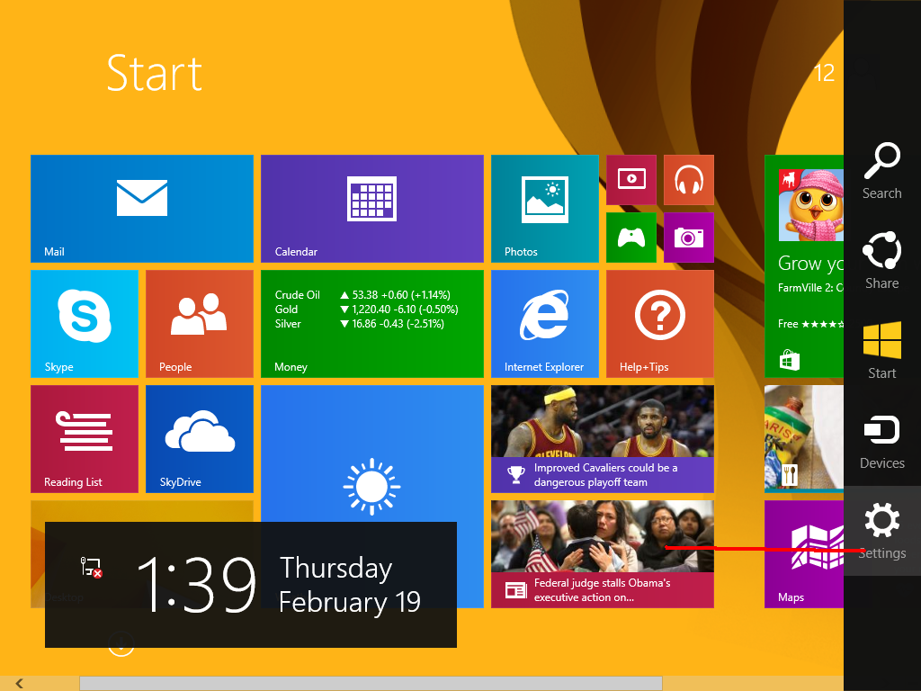
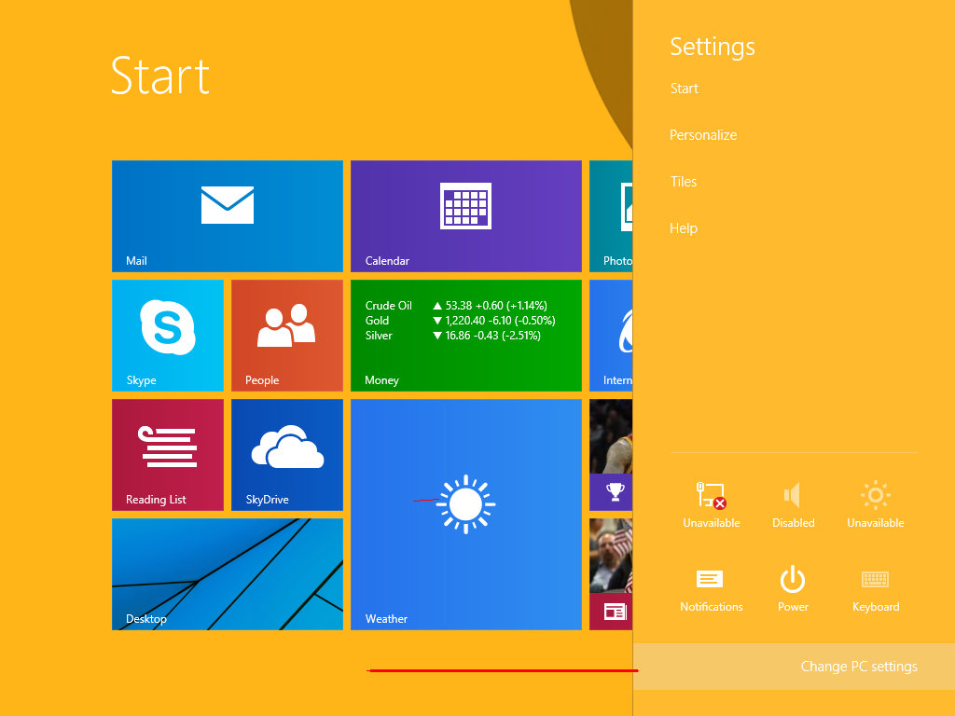

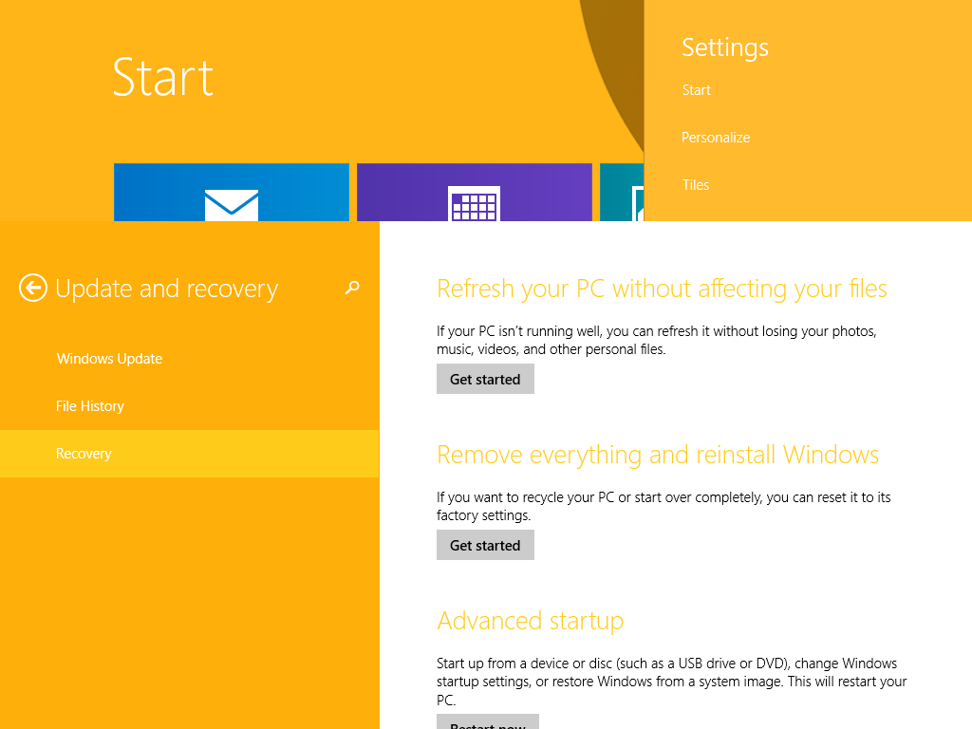

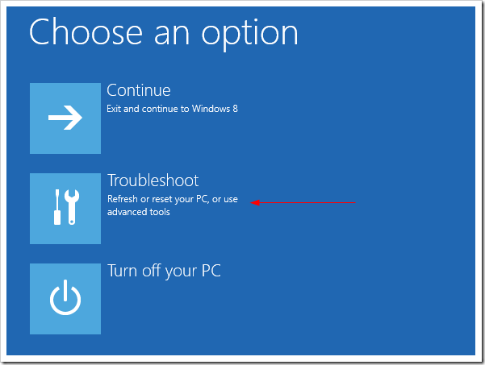
And click Advanced Options at next screen.
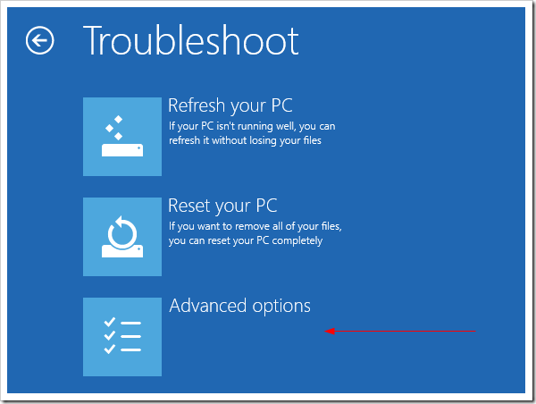
Choose Startup Settings next,
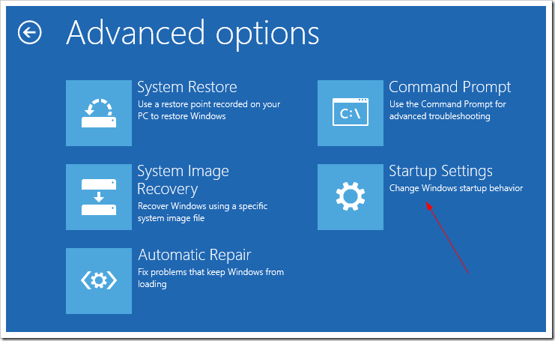
And click Restart button.
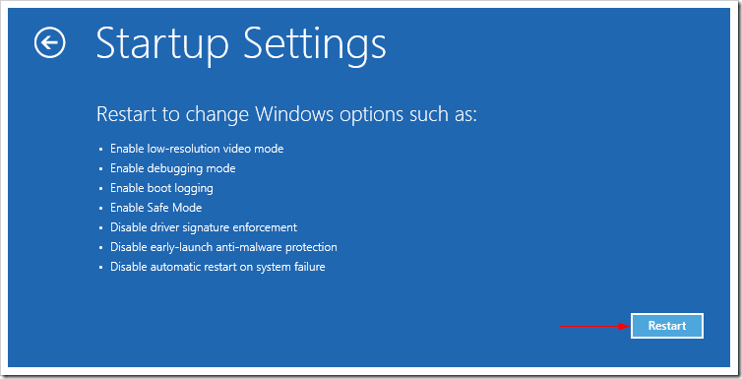
The computer reboots and prompts another menu to choose. One of the items is to Disable driver signature enforcement. Press number 7 or F7 to continue booting to Windows 8 with digital sign enforcement disabled.
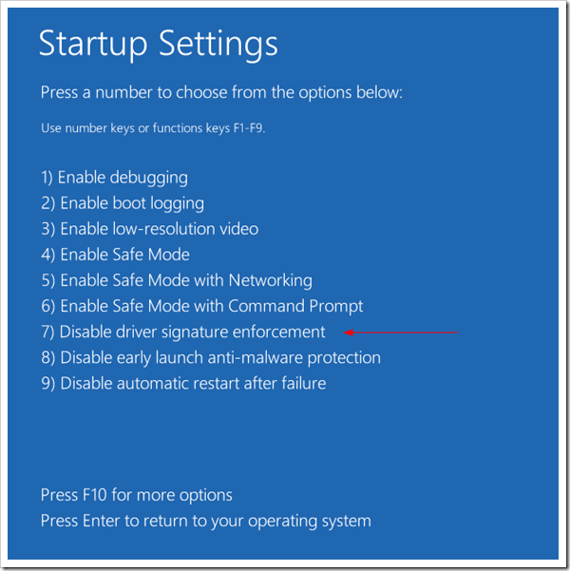
Then on Windows Security warning window offering you to install this driver anyway.
After the completion of all above steps go to below link and download the driver.
http://www.enter-multimedia.com/support.html
Step1. After successful download, please install it in your PC.
Step2. In driver folder go to AP2 folder and install setup.exe
For serial no. go to SN.TXT (in case if serial no. don’t match of SN.TXT file use the any one of following keys-
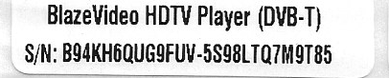
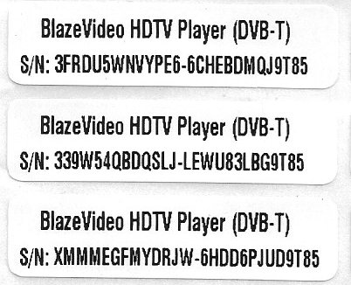
After install click on the Blaze HDTV 6.0 & Enjoy the Live TV on your PC.

